Overview
This document describes the configuration and testing of an SSL VPN remote-access solution on a FortiGate firewall.
The VPN enables secure remote connectivity to the Management Network (VLAN50) using encrypted SSL VPN tunnels.
Users authenticate with a local FortiGate account and receive a virtual IP from a dedicated SSL VPN address pool.

Configuration Summary
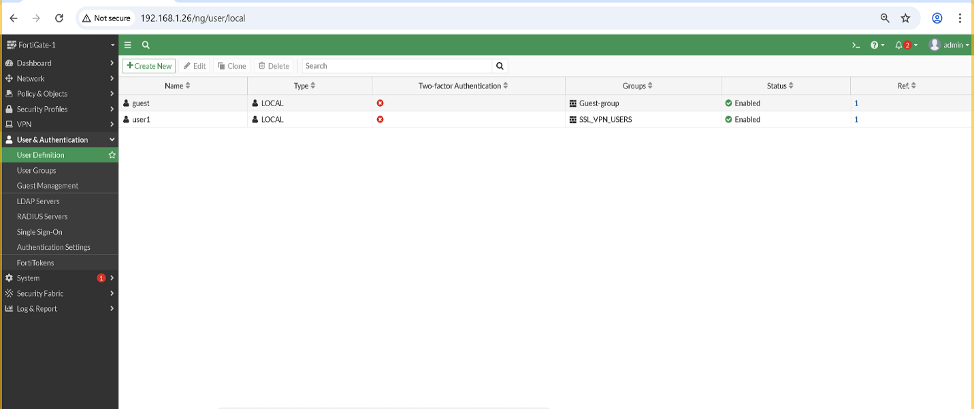
Local User
- Username: user1
- Type: Local User
- Two-Factor Authentication: Disabled
- Status: Enabled
This user is the account remote users will use to log in.

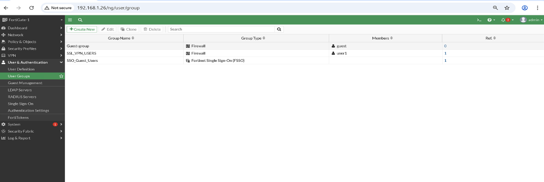
User Group
- Group Name: SSL_VPN_USERS
- Group Type: Firewall group
- Members: user1
This group is mapped to the SSL VPN portal.

Address Objects
SSL VPN IP Pool
- Name: SSLVPN_TUNNEL_ADDR1
- Type: IP Range
- Purpose: IPs assigned to remote VPN clients
Internal Subnets
- VLAN50 Address → Management network (VPN destination)

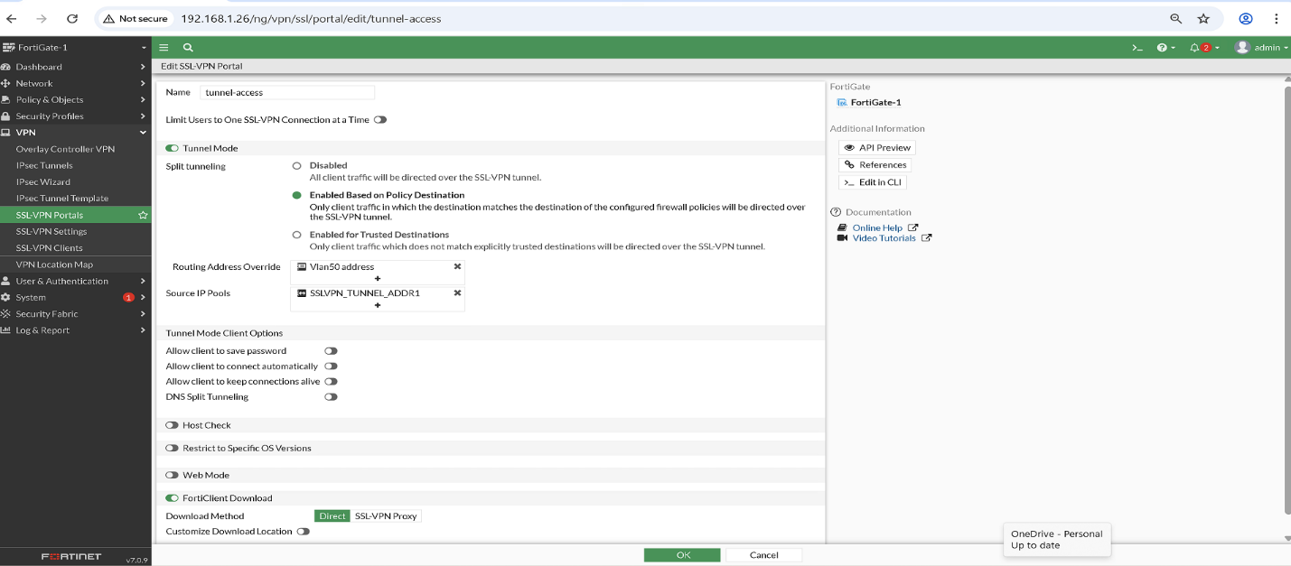
SSL VPN Portal Configuration
Portal Name: tunnel-access
Mode: Tunnel Mode Only
- Tunnel mode: Enabled
- Web mode: Disabled
Split Tunneling: Enabled
- Split tunneling based on destination
- Traffic to the internal network goes through VPN
- Internet traffic goes out through the user’s local connection
Routing Address Override: Vlan50 Address
(VPN users receive a route to the management subnet.)
Source IP Pool: SSLVPN_TUNNEL_ADDR1

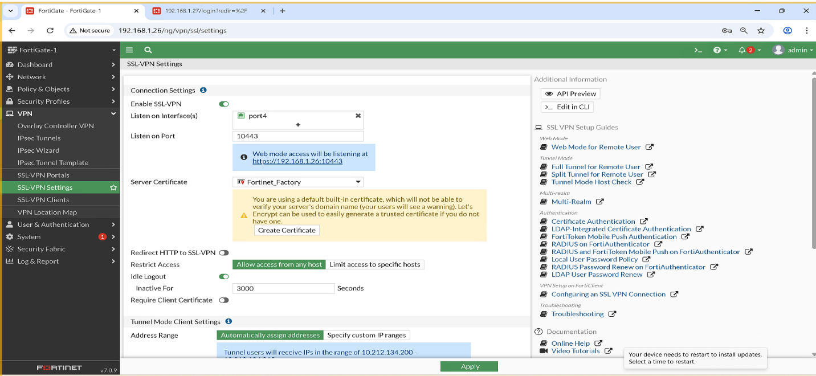
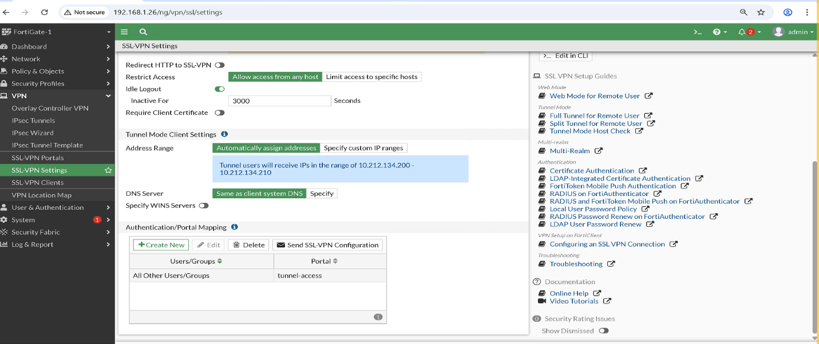
SSL VPN Settings
Listen on Interface: port4
Listen on Port: 10443
(Chosen to avoid conflict with Admin HTTPS port 443.)
Server Certificate: Fortinet_Factory
Idle Timeout: 3000 seconds
Restrict Access: Allow from any host
Address Range: Automatically assign from IP pool
Authentication / Portal Mapping
- All Other Users/Groups → tunnel-access
This ensures all users in SSL_VPN_USERS get the correct portal.

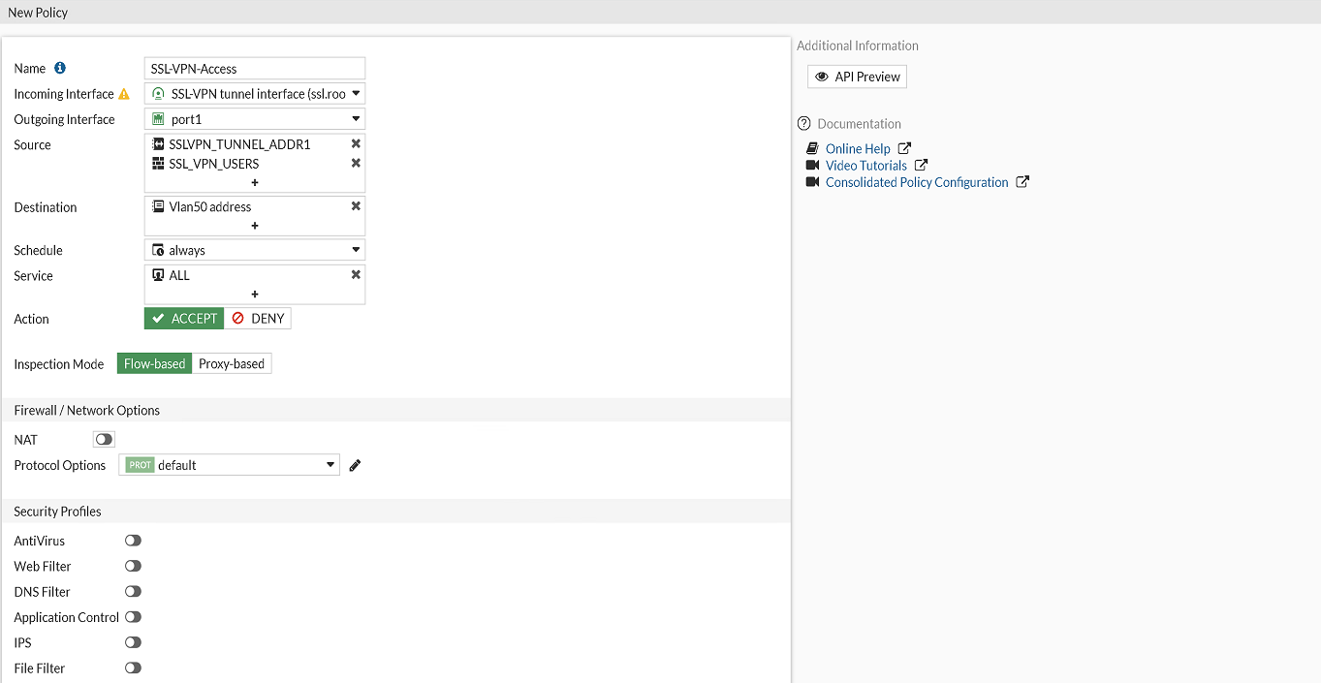
SSL VPN Firewall Policy
A single firewall policy allows VPN traffic to reach the management network.
Policy Name: SSL_VPN_Access
Incoming Interface: ssl.root (SSL VPN Tunnel Interface)
Outgoing Interface: port1
Source:
- SSLVPN_TUNNEL_ADDR1 (client IP pool)
Destination:
- Vlan50 Address (management subnet)
Services: ALL
NAT: Disabled
Inspection Mode: Flow-based
User Group: SSL_VPN_USERS
This policy ensures that:
- Only authenticated VPN users get access
- Only traffic to VLAN50 is allowed
- No access to other VLANs or internal resources

Expected SSL VPN Test Results
- Web Portal Access
  - When entering the public IP/port of the FortiGate (https://192.168.1.26:10443), the SSL VPN login page should appear.
  - A security warning may appear because the certificate is self-signed.
- FortiClient Authentication
  - User enters username + password created in FortiGate.
  - The client establishes an SSL tunnel.
  - A private VPN IP from the SSL VPN address pool is assigned.
- Post-Login Connectivity
  - User can ping internal servers or PCs in the main site LAN.
  - User can access internal resources allowed by the SSL policy.
- Logs
  - FortiGate event logs show “Tunnel Up”.
  - User is listed under “Monitor → SSL VPN Monitor”.

Partial / Planned Results (Actual Testing Done or Verified)
- Internet connectivity from FortiGate WAN verified.
- SSL VPN configuration completed (portal, authentication, users, firewall policy).
- Browser test (planned via Client VM) would show “Connection not secure” due to self-signed certificate.
- FortiClient connection (planned via Client VM) would establish tunnel and assign VPN IP.
Note: Due to lab setup limitations, actual end-to-end SSL VPN tests from a separate Client VM in GNS3 were planned but not executed. The results above are expected outcomes based on configuration and standard behavior.

Challenges / Problems Encountered
- Testing SSL VPN from a separate Client VM
  - The GNS3 Cloud in our lab is not bridged to a real NIC, so adding a Client VM to simulate a remote user would require significant topology changes. Changing the topology just before submission could have affected stability.
- Browser security warnings
  - Accessing the SSL VPN portal through a browser triggered warnings due to the self-signed certificate. This is expected behavior and does not indicate a configuration error.
- FortiClient connectivity (planned)
  - Installation and configuration of FortiClient on a separate VM were prepared but not executed, as the topology changes required were considered high-risk before submission.

